**Taha Jawaid**

**K213881**

**Deliverables**

1. **Bucket Name**: Provide the name and region of the bucket created.

1. **Bucket Policy**: Submit a screenshot or JSON output of the bucket policy used for public access.

1. **Object URLs**: Provide the public URLs of at least two different objects (e.g., an HTML page and an image).

Object url = <https://s3labtaha.s3.us-east-2.amazonaws.com/index.html>

Object url = <https://s3labtaha.s3.us-east-2.amazonaws.com/Screenshot+(22).PNG?versionId=p0mfNrxbfBI836p7QPqNZMg.x0UOKchJ>

1. **Versioning**: Submit evidence (screenshot) that versioning is enabled, and show that an object version has been updated.

1. **Lifecycle Policy**: Submit a screenshot or configuration details of the lifecycle policy for transitioning objects to a different storage class.

1. **Static Website URL**: Submit the public URL of the static website hosted on S3.

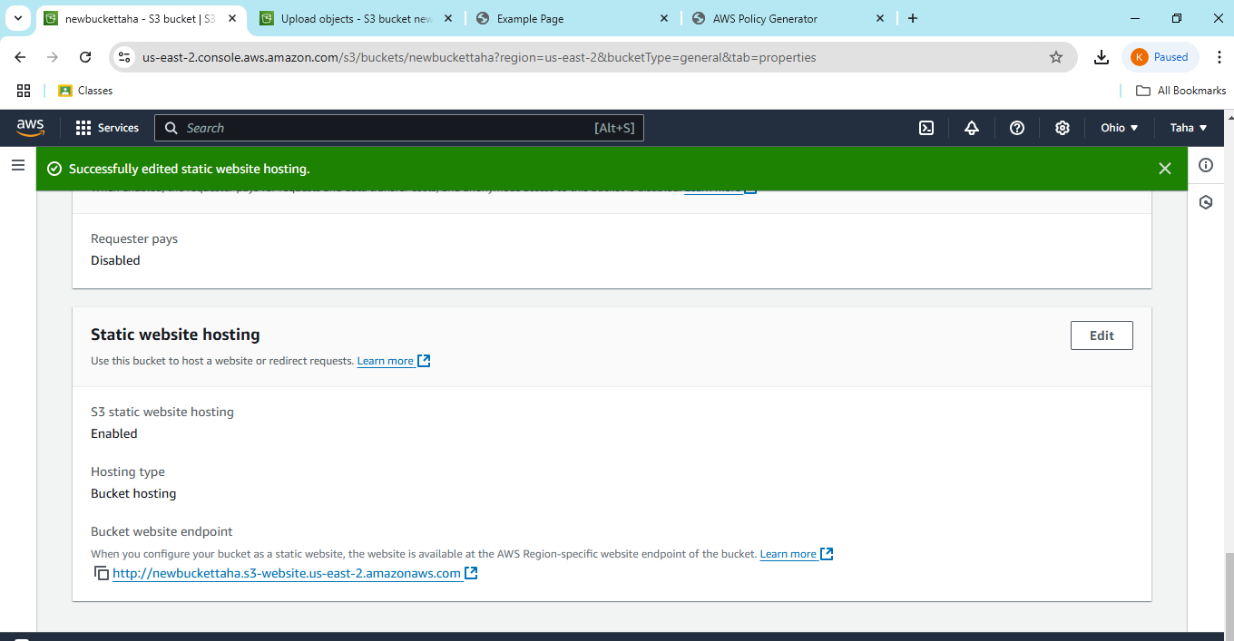

Url = http://newbuckettaha.s3-website.us-east-2.amazonaws.com